**Project: Flyaway (An Airline Booking Portal)**

**By: Robert Hertel**

**Note this project was done working off of videos that simplilearn earlier sent me when I was off. It uses SQL 5 and Eclipse Mars**

**Sprint 1 - Develop Admin Password And Login Functionality**

Develop a screen that allows you to login

* Link to Admin Password Change
* If login go to session dashboard (which gives several flights to choose from). Otherwise go to Session Handling Screen that tells you that you didn’t login in

Develop Session Handling Screen that if the login fails lets you know

* Link to Admin Password Change

Develop A logout screen

* Invalidates the session that contained your name and password
* Gives you a link back to the login screen

Start the session dashboard (which gives several flights to choose from)

* From this screen you should be able to logout and choose flights

**Sprint 2 - Develop Rest of App - List of flights and all details, Register Details, Booking Table Showing all Tables, and Final Acceptance**

Ensure Dashboard screen has all the details of the flight and allow a user to choose the correct flight

* The user name and password are null and whitespace checked going into the Session Dashboard Screen
* It does a check against the login table that the user name and password are correct using a prepared statement
* If you choose a checkbox that is the flight you have selected
* Press Submit after selecting a checkbox.
* Then go and register personal details link to go to the next screen

In the Personal Register Details Screen get the user to fill in the data that gets inserted in to the Register Details Table

* Need a prepared statement to insert data into sql table
* Link to the next screen after the details have been entered

In the Booking screen need to join all of the data from the earlier tables on the screen together to show the user all the flight and personal register details

* Need a prepared statement to insert data into sql table
* After have a link to the Final Acceptance Screen

On the Final Acceptance screen show the final confirmation

**Work From Sprint 1:**

Login:

My SQL Table:

Enter with KraigMuller@gmail.com and password pass123:

Logout:

Login Again:

Login with wrong details:

Change Password with Admin Login:

Admin Password change:

State of the Login Table after Password Change:

Algorithms Search and Sort:

-The admin name and password are null and whitespace checked

-The user name and password are also null and whitespace checked

-If a login isn't correct you are redirected to a screen where the application indicates you need the correct username and password.

-A prepared statement is used to update the Admin SQL table

**Work From Sprint 2:**

After login in get the Session Dashboard Screen:

There you can choose between several flights with prices and destinations. I chose the 1st flight:

In the SQL the values are displayed from here:

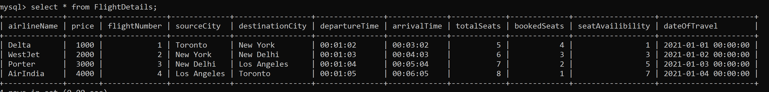

Then pressed Register Personal Details:

Where I filled in all these personal details and after pressing submit they showed up below:

This got stored in the following SQL table:

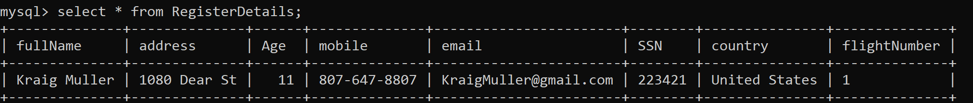

All the information is joined in a booking table and that is displayed here:



The user thereafter states that the information is correct and taken to this page:

Algorithms Search and Sort for Sprint 2:

-The user name and password are null and whitespace checked going into the Session Dashboard Screen

-It does a

-If a login isn't correct you are redirected to a screen where the application indicates you need the correct username and password.

-A prepared statement is used to update the Admin SQL table

-The RegisterDetails Page Also uses a prepared statement for insertions

**Link to Github Repository:** https://github.com/RFHertel/SimpliLearn-PG-FSD-Become-a-back-end-expert